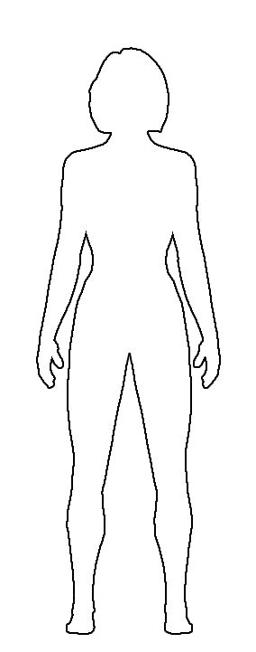
We need a Superhero to save the Harmer Hill Village Show.
It is up to you to create one......Please help!
Create a superhero and add a background. Put your name and age on the back of the picture.....Thanks for your help.

